**Name:** Chitikina Lakshmi Durga

**Automation Scenario:** OrangeHRM

**Tools**: Postman, Cypress

Prerequisite:

Download a Postman Application Tool

URL- <https://dl.pstmn.io/download/latest/win64>

API - Document

<https://docs.github.com/en/rest/repos/repos?apiVersion=2022-11-28#list-organization-repositories>

**API -GET\_METHOD**

**Steps:**

1. Create a new workspace “API\_Exercise” and create a new collection “Testing”.
2. Refer the document for Methods URL.
3. Generated a new classic token in GitHub.
4. Created a variable for token.
5. Added a request “Get\_Method” in Testing collection and select a GET method.
6. Given an authorization token variable.
7. Added few test cases in tests.
8. Then Save and Send.

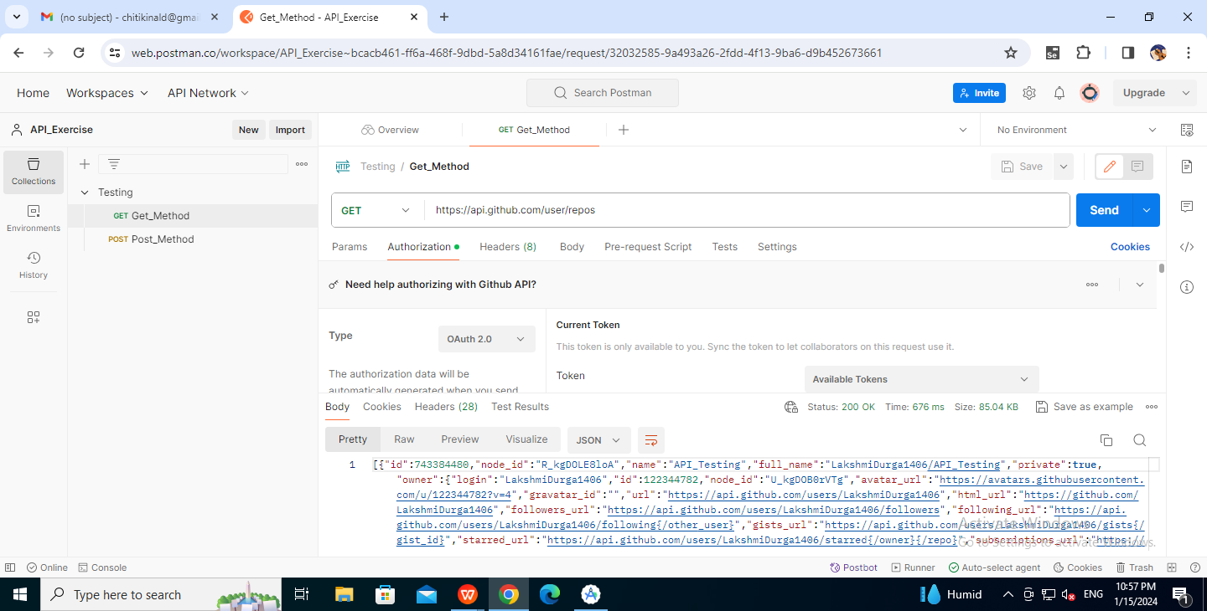

**API -POST\_METHOD**

**Steps:**

1.Refer the document for POST Methods URL.

2.In the workspace “API\_Exercise” and in a collection “Testing”.

3.Added a request “Post\_Method” in Testing collection and select a POST method.

4.Given an authorization token variable.

5.Added few test cases in tests.

6.Added the script in body.

7.Then Save and Send.

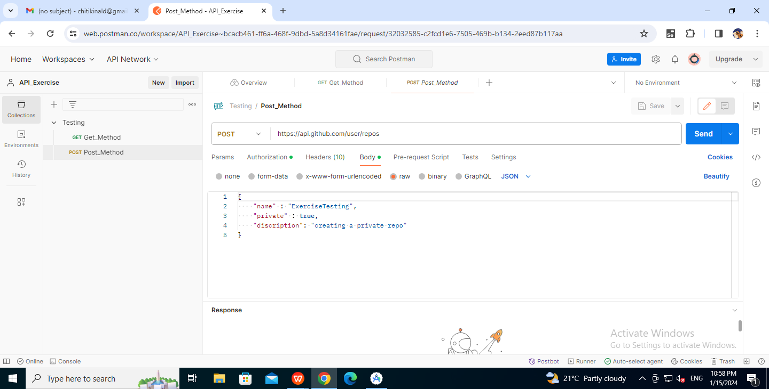

**Execute test using newman**

**Prerequisite:**

Export the collection file from postman.

**Set Environment:**

Install newman by using:

npm install -g newman

Then execute the following command to run the collection file.

newman run collection file.json

Example:

newman run Testing.postman\_collection.json

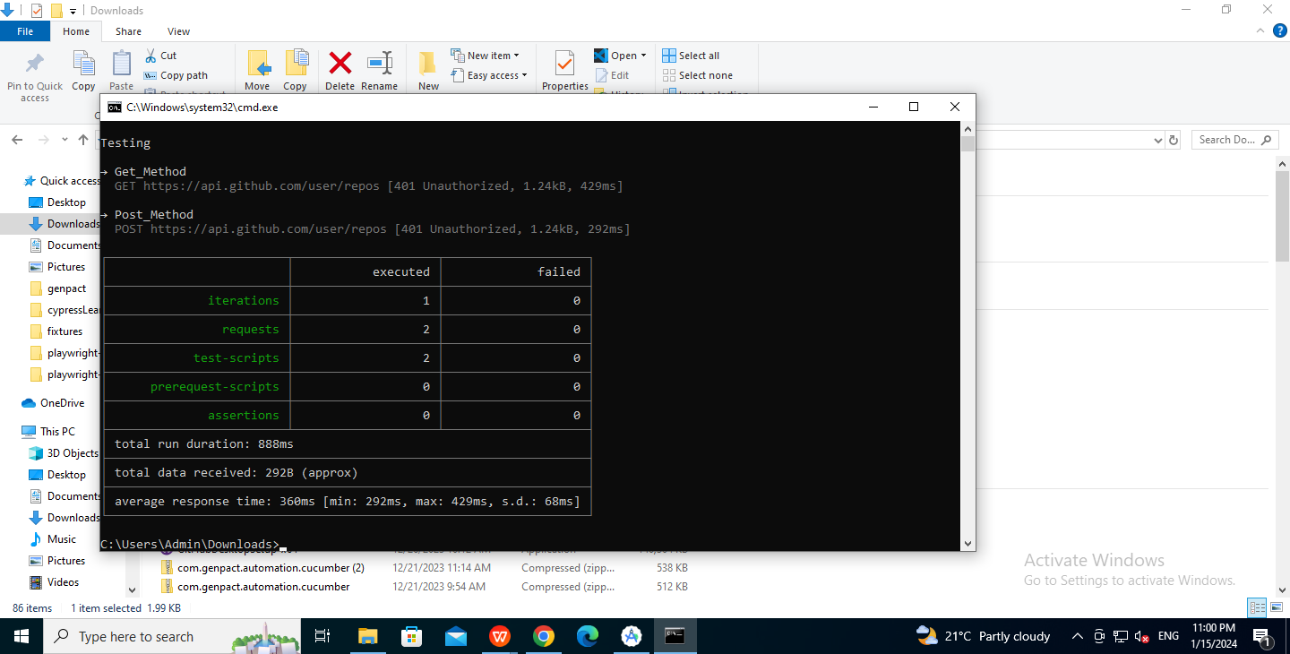

**Generate a HTML report**

**Set Environment**

Install newman reporter htmlextra by using:

npm I -g newman reporter htmlextra

Then execute the following command to get the html report:

Newman run collection file.json -r htmlextra

Example:

newman run Testing.postman\_collection.json -r htmlextra

Then a folder newman gets created where we can see following report.

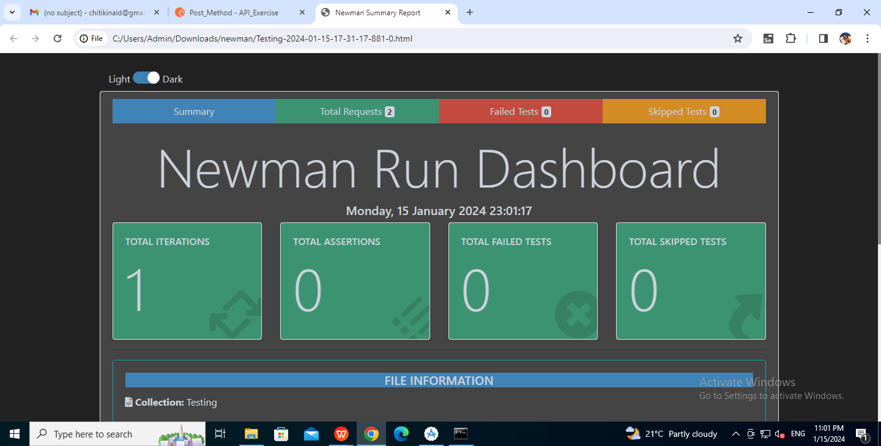

1. **WebApp Automation**

-Cypress Tool

**Prerequisite:**

NodeJS

NPM

VScode

**Set Environment:**

-Go to VScode and create a new folder for Cypress Automation Learning.

-Inside this folder install the package.json files by using following command in terminal.

npm init -y

So that inside this file all the default packages get installed.

-Now install the Cypress using the command in terminal

npm install cypress --save-dev

-Now the cypress get installed.

-In order to open the cypress application we need to give the following command in terminal after installation.

npx cypress open

-Create a new \\*spec.cy.js file in cypress and run it. Then it creates a file in e2e folder in cypress in VScode.

- There in e2e folder we can create new folder and execute different files.

**Application ------ OrangeHRM**

URL - <https://opensource-demo.orangehrmlive.com/web/index.php/auth/login>

**Steps:**

1. Create a folder “Exercise\_Learning” under e2e.
2. Create a file “OrangeHrm” under the folder “Exercise\_Learning”.
3. Write the code inside this file. This code includes:

-Launching an application.

-Verifying application title and url.

-Give the username and password.

-Click on Login.

-Verifying application title and url.

-Click on Logout.

-Verifying application title and url.

-If we want to take a screenshot and record the execution, then we can add the following lines in cypress.config.js file

screenshotOnRunFailure: false,

Video: true

-Then we can have a execution video in the videos folder.

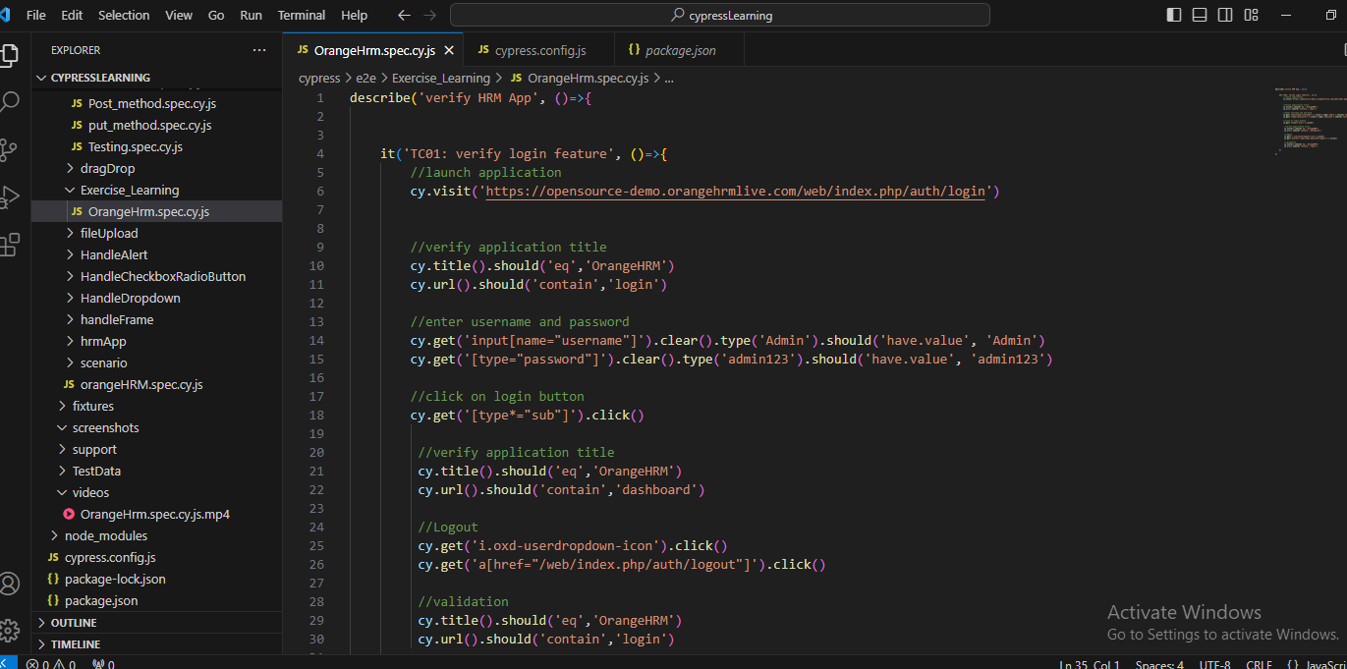

1. Save the file.
2. Open the terminal and give the below command.

npx cypress run --spec ./cypress/e2e/FolderName/FileName --browser chrome --headed

Example:

npx cypress run --spec ./cypress/e2e/Exercise\_Learning/OrangeHrm.spec.cy.js --browser chrome --headed

(Or)

npm run Keyword

-We can create the keyword in package.json file by giving the complete path.

“ExerciseTesting”: “npx cypress run --spec ./cypress/e2e/Exercise\_Learning/OrangeHrm.spec.cy.js --browser chrome --headed”

-Here the keyword is ExerciseTesting

Example:

npm run ExerciseTesting

1. Click on Enter, so that we get the following output.

**Output in Terminal:**

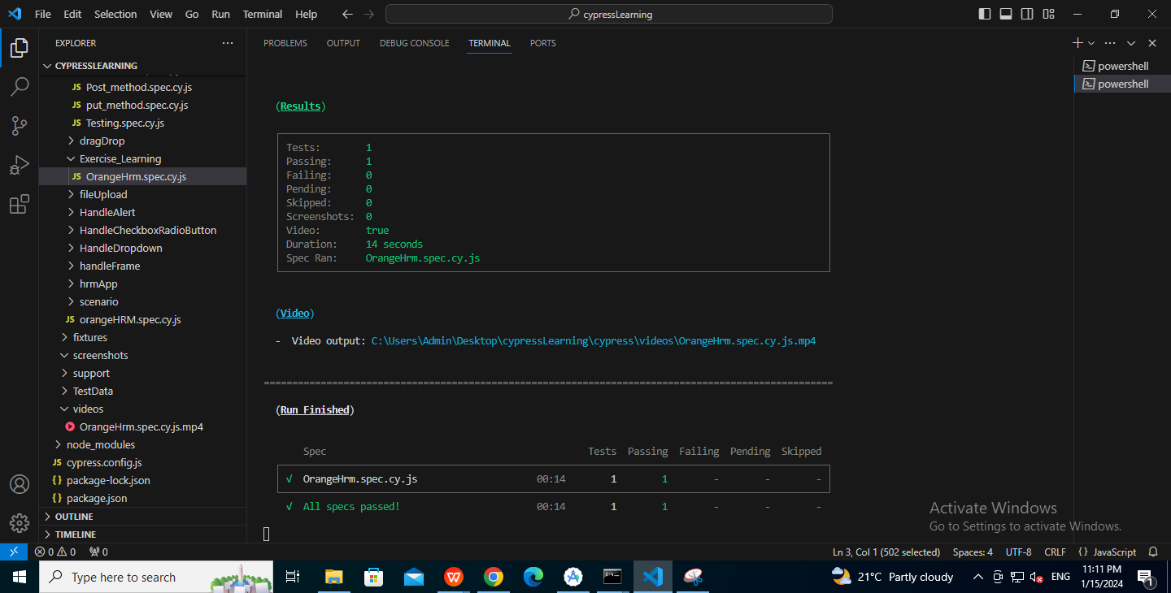

**Output in Cypress:**

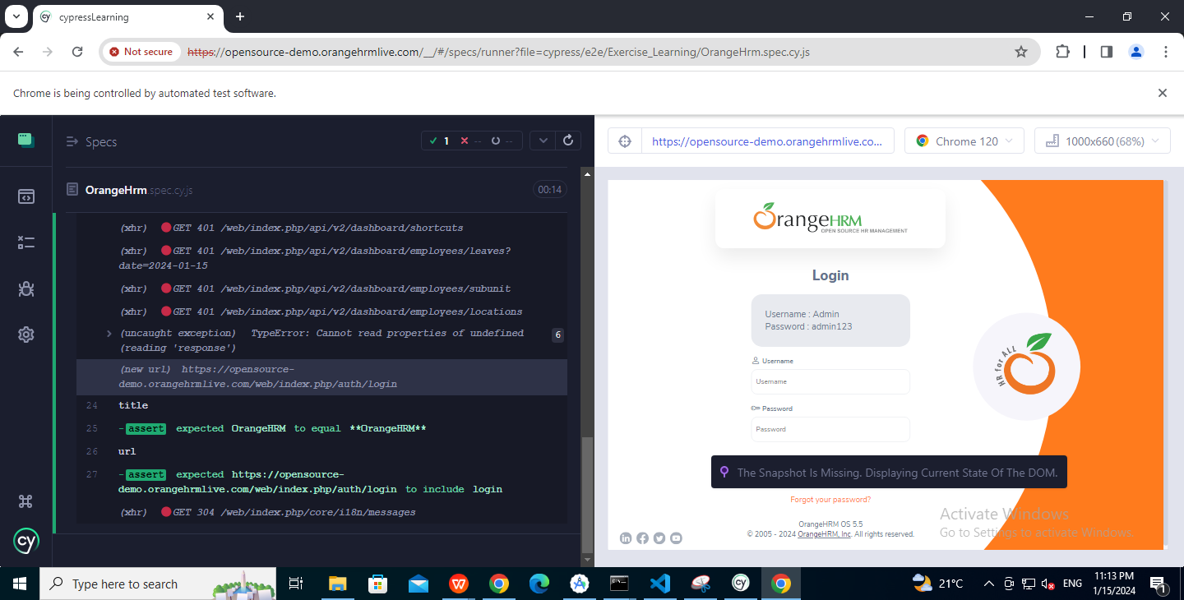

**Video Screenshot:**

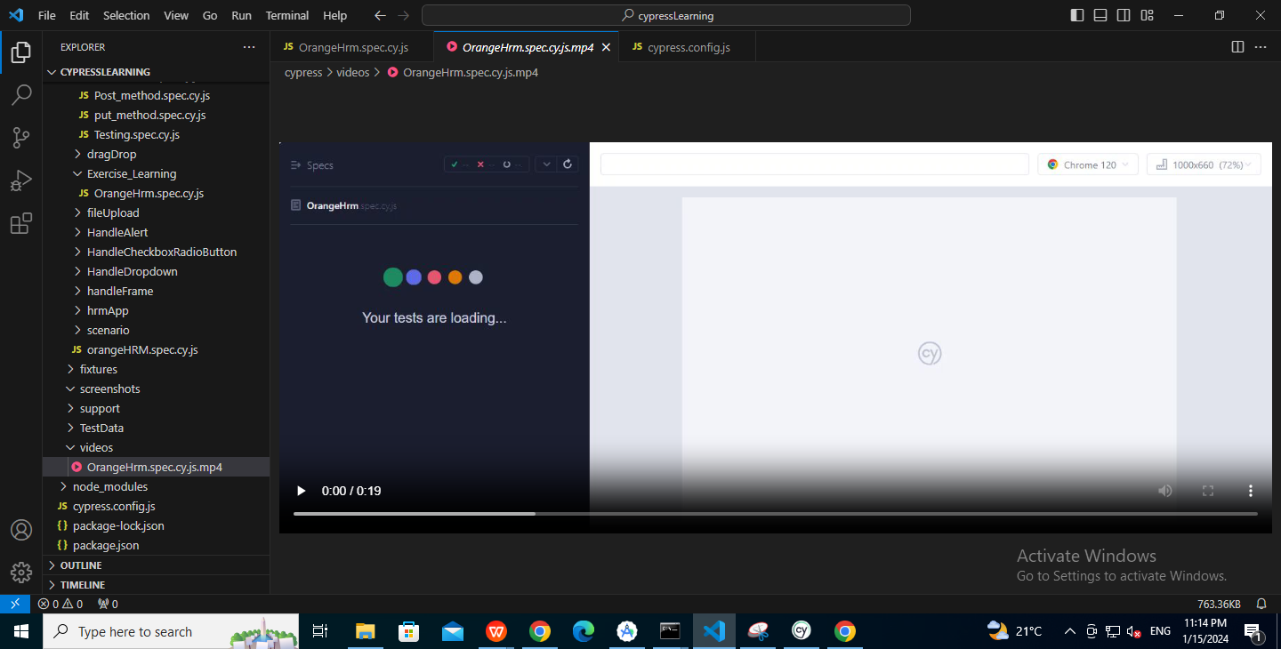

**3.Jenkins**

**Prerequisite:**

Installed java version should be 11 or above.

Download and Install

1) Installer

-Download

[https://www.jenkins.io/download/thank-you-downloading-windows-installer-stable](https://www.jenkins.io/download/thank-you-downloading-windows-installer-stable" \t "https://mail.google.com/mail/u/0/?tab=rm&ogbl" \l "inbox/_blank)

-Verify port information

netstat -a

-Default localhost:8080

-Install suggested plugin

2)Generic war file

-Download

<https://get.jenkins.io/war-stable/2.426.2/jenkins.war>

-Verify port information

netstat -a

-Default localhost:8080

-Install suggested plugin

**a) Execute API test**

**Steps:**

1. Go to Jenkins and create a new item which is Freestyle project.

2. In General section go to Advanced, select the Use custom workspace and give the exported file path(example: C:\Users\Admin\Downloads).

3. Go to Build Steps, Add build steps and select Execute Windows batch command.

4. Give the command newman run collection file.json (example: newman run Testing.postman\_collection.json)

5. Apply and Save.

6. Click on Build now

1. After completing the execution, open console output and check.

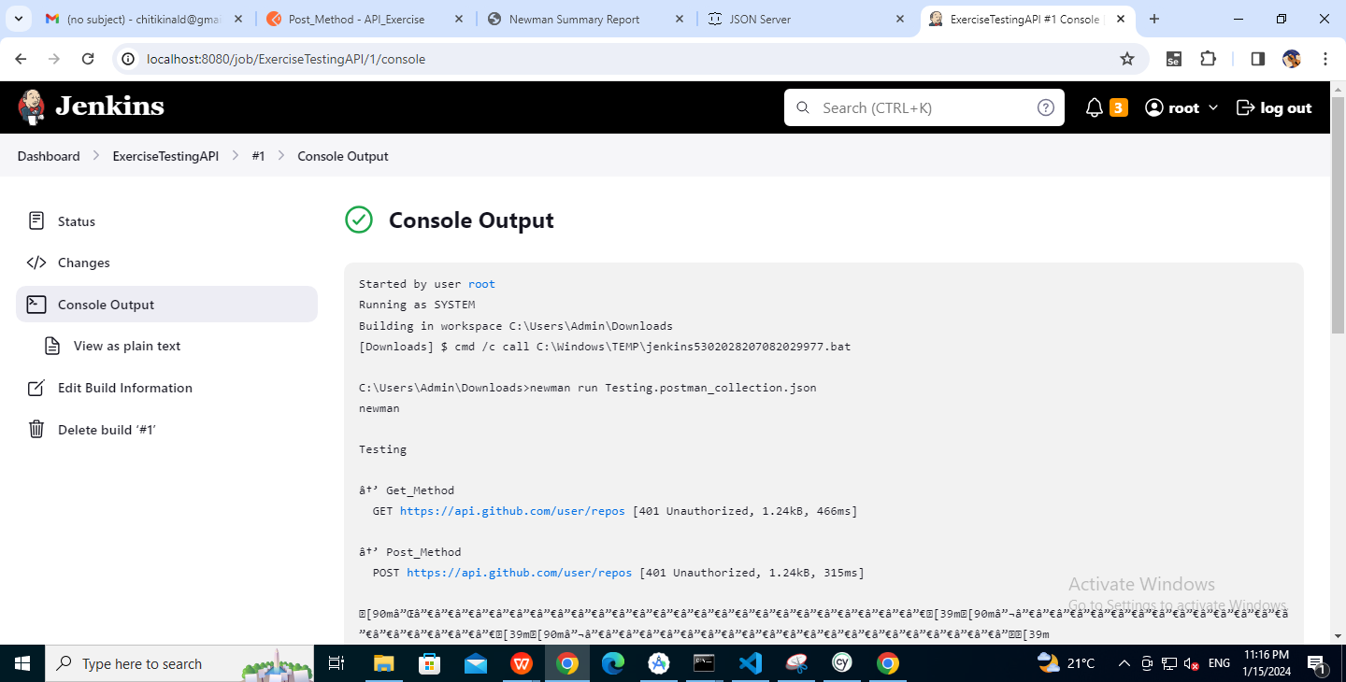

**b) Execute WebApp test**

Integration with Jenkins:

**Steps:**

1. Go to Jenkins and create a new item which is Freestyle project.

2. In General section go to Advanced, select the Use custom workspace and give the exported file path(example: C:\Users\Admin\Desktop\cypressLearning).

3. Go to Build Steps, Add build steps and select Execute Windows batch command.

4. Give the command:

npx cypress run --spec./cypress/e2e/FolderName/FileName --browser chrome --headed

Example:

npx cypress run --spec

/cypress/e2e/Exercise Learning/OrangeHmm.spec.cy.js --browser chrome --headed

(Or)

npm run Keyword

-We can create the keyword in package.json file by giving the complete path.

"Exercise Testing":"npx cypress run-spec /cypress/e2e/Exercise\_Learning/OrangeHrm.spec.cy.js --browser chrome --headed"

-Here the keyword is Exercise Testing

Example:

npm run Exercise Testing

5. Apply and Save.

6. Click on Build now

1. After completing the execution, open console output and check.

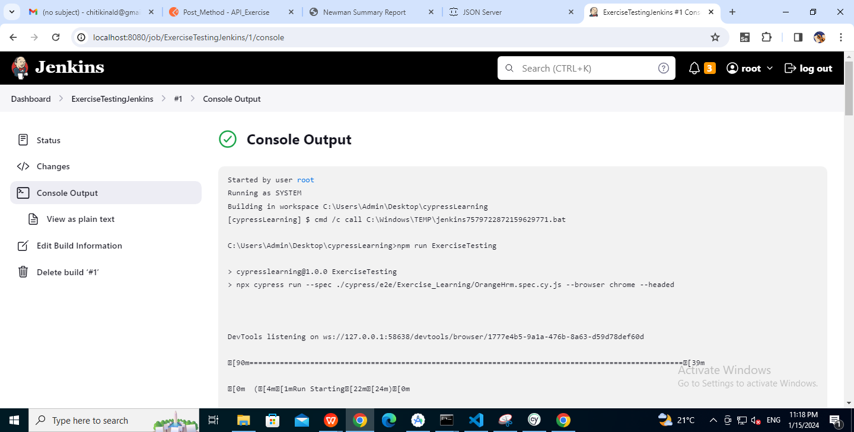

**c) Execute WebApp test**

Integration with GitHub:

**Prerequisite:**

GitHub Desktop application

GitHub account

Create a new repository and push the complete cypress folder into repository.

**Steps:**

1. Go to Jenkins and create a new item which is Freestyle project.

1. Under Source Code Management select Git and give the GitHub repository Url.
2. Go to Build Steps, Add build steps and select Execute Windows batch command.

4. Give the command:

npx cypress run-spec./cypress/e2e/FolderName/FileName --browser chrome --headed

Example:

npx cypress run-spec /cypress/e2e/Exercise Learning Orange Hrm.spec.cy.js --browser chrome --headed

Or

npm run Keyword

-We can create the keyword in package.json file by giving the complete path.

"Exercise Testing":"npx cypress run-spec /cypress/e2e/Exercise\_Learning/OrangeHrm.spec.cy.js --browser chrome --headed"

-Here the keyword is Exercise Testing

Example:

npm run Exercise Testing

5. Apply and Save.

6. Click on Build now.

1. After completing the execution, open console output and check.

